

Kifaru: A Secure Payment and Inventory Tracking Platform for Modern Merchants

By
Ochanda Charles Otieno
22YAD106743

Supervisor: Mr Paul Mwaniki

A Project Proposal Submitted in Partial Fulfilment of the Requirements for the Degree of Computer Science, School of Computing Sciences Riara University Nairobi, Kenya

Date Submitted: October, 2025
DECLARATION
I declare that this or any other University has not previously submitted this work for the awarding of the course marks. To the best of my knowledge and belief, this work contains no material previously published or written by another person except where due reference is made.

Student Name:
………………………………………….
Signature:
………………………………………….
Date:
………………………………………….

APPROVAL
This project proposal of student, Ochanda Charles Otieno, was conducted under our supervision and is submitted with our approval as university supervisors.
Supervisor Name: Mr. Paul Mwaniki
Signature: …………………
Date: ……………………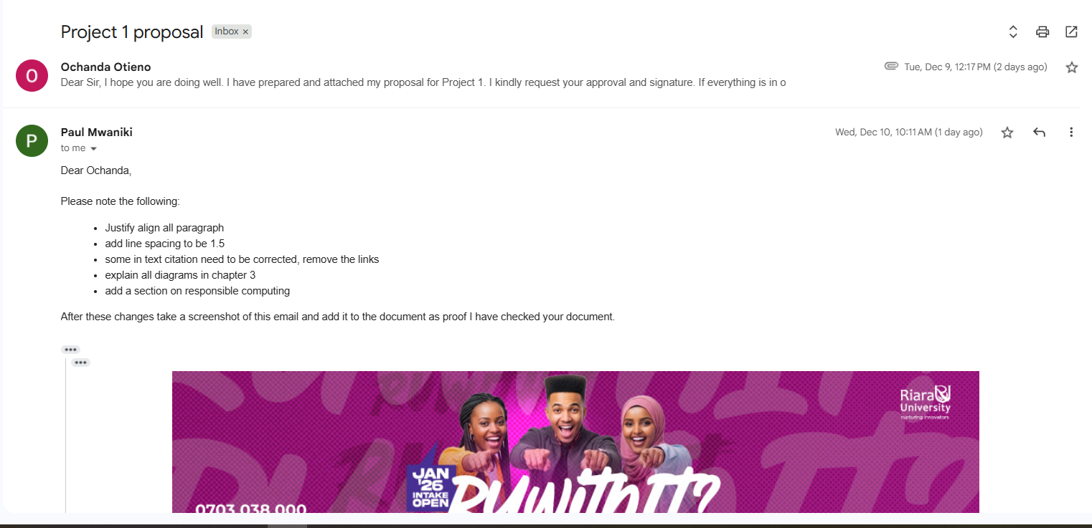

DEDICATION
I dedicate this project to my beloved family for always supporting and being there for me when I needed most.

ACKNOWLEDGEMENTS
I would like to thank my supervisor, Mr Paul Mwaniki, for always guiding me throughtout my project.

ABSTRACT
Small and medium-sized merchants are essential to local economies, yet many still struggle with accurate payment recording and inventory management. Traditional methods such as handwritten notes and manual stock checking often lead to misplaced information, inconsistencies, and limited insight into business performance. This project introduces Kifaru, a digital system designed to streamline how merchants track their sales and manage their stock.
With Kifaru, customers continue paying in the Kenyan Shilling (KES) using M-Pesa — a method they are already familiar with — while merchants receive the equivalent value securely in USDT, a stable digital currency. This helps protect business income from inflation and banking delays, while ensuring quicker access to funds. Every payment is automatically recorded in the system, and inventory adjusts in real time whenever a sale occurs, improving accuracy and reducing the risk of running out of essential items.
The platform offers secure access, role-based features, and easy-to-read dashboards that display sales history and stock levels at any moment. By digitizing financial records and automating inventory tracking, Kifaru enables merchants to operate more efficiently, maintain transparency, and make better decisions based on accurate data.
Overall, the Kifaru system demonstrates how simple digital tools can significantly enhance everyday business operations, empowering merchants to grow confidently in a rapidly evolving market

DEFINITION OF TERMS
Automated Inventory Tracking: A digital system that updates stock levels in real-time without manual intervention, triggered by sales transactions or other predefined events.
Cryptocurrency: A digital or virtual currency that uses cryptography for security and operates independently of a central bank or government authority.
Currency Depreciation: The decrease in value of a country's currency relative to other currencies, resulting in reduced purchasing power over time.
Digital Payment Platform: An electronic system that enables users to conduct financial transactions without physical exchange of cash, typically through mobile devices or computers.
Inflation: The rate at which the general level of prices for goods and services rises, causing purchasing power of currency to fall over time.
Inventory Management: The systematic approach to sourcing, storing, and tracking goods and materials, ensuring optimal stock levels for business operations.
Liquidity: The ease with which an asset or security can be converted into cash without affecting its market price.
Merchant: An individual or business entity that sells goods or services to customers, typically operating in retail or wholesale trade.
Mobile Money: A technology that allows people to receive, store, and spend money using a mobile phone, without requiring a traditional bank account.
Point of Sale (POS): The physical or digital location where a retail transaction is completed, including payment processing and record-keeping.
Reconciliation: The process of comparing and matching different sets of financial records to ensure consistency and accuracy between payment receipts and inventory records.
Remittance: The transfer of money from one party to another, often across borders, typically referring to money sent by workers to their home countries.
Stable-Value Digital Cash: Digital currency instruments designed to maintain a stable value by being pegged to a reserve asset such as the US Dollar, protecting against local currency volatility.
Stablecoin: A type of cryptocurrency designed to minimize price volatility by being pegged to a stable asset, commodity, or fiat currency.

LIST OF ABBREVIATIONS AND ACRONYMS
API – Application Programming Interface: A set of protocols and tools that allows different software applications to communicate with each other.
APA – American Psychological Association: A citation and referencing style used in academic writing.
BCG – Boston Consulting Group: A global management consulting firm.
CBK – Central Bank of Kenya: The monetary authority responsible for regulating Kenya's financial sector and maintaining currency stability.
CSS – Cascading Style Sheets: A styling language used to describe the presentation of web documents.
DFD – Data Flow Diagram: A graphical representation showing how data moves through a system.
ERD – Entity-Relationship Diagram: A visual representation of the relationships between entities in a database.
FSD – Financial Sector Deepening: An organization focused on improving financial inclusion and market development.
GSMA – GSM Association: A global organization representing mobile network operators and related companies.
HTML – HyperText Markup Language: The standard markup language for creating web pages.
JSON – JavaScript Object Notation: A lightweight data interchange format.
KES – Kenyan Shilling: The official currency of Kenya.
KRA – Kenya Revenue Authority: The government agency responsible for tax collection in Kenya.
M-Pesa – Mobile Pesa (Swahili for "mobile money"): A mobile phone-based money transfer service in Kenya.
POS – Point of Sale: The location where a transaction is completed.
SDK – Software Development Kit: A collection of software tools and libraries for developing applications.

LIST OF FiGURES
Figure 1: Entity relationship diagram 19
Figure 2: Class Diagram 19
Figure 3: Data Flow Diagram 20
Figure 4:Use case Diagram 20

LIST OF TABLES
Table 1: Agile methodology implementation plan 13
Table 2: Problem Summary 14
Table 3: Schedule feasibility 16
Table 4: Technical Feasibility 17
Table 5: Economic Feasibilty 17

TABLE OF CONTENT
CHAPTER 1 : INTRODUCTION 1
1.1 : Background Information 1
1.3 Objectives 2
1.3.1 Main Objective 2
1.3.2 Specific Objectives 2
1.2 : Justification 3
1.3 : Scope 3
CHAPTER 2 : LITERATURE REVIEW 4
2.1 : Introduction 4
2.2 : Case study — Valiu: a remittance-first stable-value solution and what it means for Kifaru 10
Overview 10
Business model and core features 10
Technology and operations (high-level) 10
Impact and outcomes (evidence and caveats) 10
Strengths (what worked) 11
Weaknesses and limitations (why it is not a full Kifaru competitor yet) 11
Relevance to Kenya and Kifaru’s design choices 11
Direct lessons for Kifaru (actionable takeaways) 12
Conclusion of case study 12
CHAPTER 3 : METHODOLOGY, ANALYSIS AND DESIGN 13
3.1 : Introduction 13
3.2 : System Development Methodology 13
3.3 : SDLC Framework with Agile Implementation 13
3.4 : Methodology Selection Rationale 14
3.5 : System Analysis 14
3.6 : Stages of System Analysis 14
Problem Identification 14
Requirement Elicitation 15
Process Modeling 15
Data Analysis 15
Evaluation 15
3.7 : Feasibility Study 16
Schedule Feasibility 16
Technical Feasibility 17
Economic Feasibility 17
Resource Feasibility 18
3.8 : Requirement Elicitation 18
Secondary Research 18
Personal Observation 18
Merchant Interviews 18
Limitations 18
3.9 : Responsible Computing Implementation 19
User Data Protection & Privacy 19
Security and Financial Safety 19
Trust & Transparency 19
Regulatory Alignment 19
Sustainable Technology Use 19
3.10 : System Design 20
Entity-Relationship Diagram (ERD) 20
Class Diagram 21
Data Flow Diagram (DFD) 21
. Use Case Diagram 22

INTRODUCTION

Background Information
Small and medium-sized merchants in Kenya play a vital role in supporting local economies, yet they continue to face challenges that affect the growth and sustainability of their businesses. Many merchants still rely on manual methods such as handwritten receipt books, physical stock checks, and basic spreadsheets to manage sales and inventory. These traditional approaches are slow, prone to human error, and provide little visibility into overall business performance. Research shows that such methods can lead to 20–30% inventory losses due to spoilage, miscounting, and theft. This makes it difficult for merchants to track which products are profitable and to make accurate restocking decisions.
Merchants also experience financial pressure arising from the declining value of the Kenyan Shilling. Over the past five years, the currency has depreciated by about 20 percent against the US Dollar, while inflation has remained between 7 and 9 percent annually. As a result, money saved in traditional bank accounts decreases in real value over time. Savings accounts offer only 3–5 percent interest rates, which are not enough to protect earnings from rising prices. Moreover, more stable financial options, such as foreign currency accounts, are difficult for many merchants to access due to high minimum balance requirements.
Digital payment platforms like M-Pesa have greatly improved transaction convenience for customers and merchants in Kenya. However, this advancement has not fully translated into better business management. Payment records are still received as individual text messages, requiring merchants to manually update their inventory and financial records. This creates additional daily work, often 30–45 minutes spent reconciling sales and stock, which increases the chance of mistakes and makes it difficult to monitor business performance in real time.
Recent advancements in digital finance have introduced new opportunities for secure value storage that can protect earnings from local currency depreciation. These technologies allow ordinary users to hold money in a stable store of value while still keeping it accessible for everyday use. However, most available solutions focus only on either payment processing or inventory management, and do not combine both needs into one accessible system.
This project presents Kifaru, a web-based solution designed to address these challenges together. Kifaru automates inventory tracking whenever customers pay through familiar methods like M-Pesa, while allowing merchants to receive the equivalent value of those payments in a stable digital format. With no need for major changes in customer behavior or merchant technical skills, the system aims to improve operational efficiency, support better financial record-keeping, and protect earnings from depreciation. By integrating payments and inventory into one simple platform, Kifaru seeks to strengthen business resilience and support economic growth for Kenya’s merchant sector.

1.2 Problem Statement
Small and medium-sized merchants in Kenya face three major challenges that limit their business growth and overall financial stability.
First, most rely on manual record-keeping such as notebooks and basic spreadsheets, which leads to frequent errors, misplaced records, and poor visibility of stock levels. This results in 20–30% inventory losses due to spoilage, miscounts, and theft, while merchants spend 30–45 minutes daily reconciling sales and stock. Without accurate data, they struggle to monitor performance or make informed decisions about which products generate profit.
Second, merchants are increasingly affected by the declining value of the Kenyan Shilling, which has dropped about 20% against the US Dollar in the last five years. As inflation rises, savings lose purchasing power over time, and most merchants lack affordable financial tools to protect the value of their earnings.
Third, although customers commonly pay using M-Pesa, these payments are not linked to the merchant’s business records. Receipts come as separate SMS messages, requiring manual entry into stock records. This double workload causes errors, slows down daily operations, and prevents real-time tracking of revenue and inventory. Transaction fees also reduce profit margins for merchants processing many digital payments.
Together, these issues lead to operational inefficiencies, revenue leakage, and unreliable financial tracking. Therefore, there is a strong need for an integrated digital solution that automates inventory updates, centralizes business records, protects merchants’ earnings from currency depreciation, and still allows customers to continue paying using familiar local methods like M-Pesa.

1.3 Objectives

1.3.1 Main Objective
To develop a secure and user-friendly platform that enables merchants to receive payments efficiently and manage their inventory in real time..

1.3.2 Specific Objectives
➤To automate inventory tracking and sales record management
➤ To allow customers to make payments using normal currency while merchants receive value securely in USDT
➤ To provide merchants with an organized dashboard for monitoring income and stock levels
➤ To ensure secure access and reliable data storage for business operations

Justification
Kifaru addresses major operational challenges faced by merchants by offering a centralized digital solution for payment handling and inventory management. The system improves business efficiency by replacing traditional manual processes with automated record-keeping, reducing the risk of errors and loss of critical information. It also supports financial stability by ensuring that merchants receive value securely, even when customers pay using local currency.
Additionally, the platform provides merchants with easy access to accurate and real-time business data, which enhances transparency and supports better decision-making. By integrating modern digital tools into everyday operations, Kifaru aligns with ongoing efforts to promote business digitization and financial inclusion in Kenya. The system ultimately empowers merchants to operate more professionally, reduce operational burdens, and grow sustainably in a rapidly evolving business environment.

Scope
The scope of this project is designed to ensure that Kifaru is developed as a practical and achievable solution within academic and time constraints. Geographically, the system is intended for use by merchants operating in Kenya, while allowing room for potential expansion to other regions in the future.
Functionally, the system focuses on two core features: enabling customers to pay for goods in Kenyan Shillings (KES) through M-Pesa while merchants receive the equivalent value securely in USDT, and automating inventory tracking and sales record management. Advanced functionalities such as full accounting modules, mobile applications, or integration with multiple digital currencies are excluded from the initial implementation.
The system is developed as a web-based application accessible via standard browsers, with its initial deployment designed for desktop and laptop environments. These limitations maintain a manageable scope while ensuring the delivery of a minimum viable product that effectively addresses the key challenges identified in the problem statement.

LITERATURE REVIEW

Introduction
The intersection of everyday business management and modern financial technology presents an important opportunity for merchants in emerging economies. In Kenya, informal and formal retail traders—from market kiosks to established small and medium enterprises (SMEs)—operate in an environment where the convenience of digital payments has outpaced the availability of equally convenient tools for financial protection and business management. Mobile money has become the dominant medium for customer payments, but many merchants continue to rely on manual approaches for inventory and record-keeping, resulting in inefficiencies and lost value (World Bank, 2010; GSMA, 2023). At the same time, persistent inflation and currency depreciation expose merchants’ savings to steady erosion in purchasing power, creating a need for simple ways to preserve value without forcing changes to customer behaviour. This literature review examines the evolution of merchant management methods, the rise of digital payments in Kenya, the problem of currency volatility for small businesses, the emergence of stable-value digital cash as an option for preserving value, and existing platforms that attempt (partially) to solve these problems. The chapter concludes by identifying gaps in current practice and showing where a solution that integrates payment reception, automated inventory updates, and simple value protection—such as Kifaru—would fit. (World Bank, 2010; GSMA, 2023; FSD Kenya, 2024).
2.2 Traditional Merchant Management Methods in Kenya
2.2.1 Inventory tracking and record-keeping
Across Kenya, a substantial number of merchants still rely on handwritten receipt books, paper stock cards, or mental tracking to manage daily sales and inventory. These methods are inexpensive to implement but create operational fragility: paper records are easily damaged or lost, human error produces inconsistent entries, and mental systems break down during illness or staff absence (FSD Kenya, 2024). Manual approaches also make it difficult for merchants to see short-term trends, forecast demand, or identify unprofitable items—capabilities that are critical for efficient restocking and pricing decisions (FSD Kenya, 2024). International literature on small retail operations shows that automation of stock tracking typically reduces stock discrepancies, improves reorder timing, and creates audit trails that help address theft and shrinkage; the same mechanisms are applicable to Kenyan merchants but adoption is low due to cost, complexity, and device requirements (World Bank, 2010; GSMA, 2023).

2.2.2 Time burden and opportunity cost
Manual reconciliation and record-keeping consume merchant time that could otherwise be used for customer service or business development. Studies and sector reports focused on micro and small enterprises in Kenya highlight that merchants spend measurable portions of their day on bookkeeping and reconciling cash and mobile money receipts with physical stock, a practice that limits their capacity to focus on growth activities (FSD Kenya, 2024). While aggregated figures vary by business type and location, the qualitative consensus is clear: reconciliation is non-trivial and often interrupts core business tasks (FSD Kenya, 2024).
2.3 Payment Reception Methods and Their Limits
2.3.1 Cash, banks, and M-Pesa in practice
Cash remains widely used in many informal markets due to its universality and immediate liquidity. However, cash transactions expose merchants to security risks, require physical handling, and do not automatically generate a digital audit trail (World Bank, 2010). Bank transfers and formal banking are used by fewer merchants—largely because bank accounts, account fees, and transaction procedures are not always compatible with daily retail needs (FSD Kenya, 2024). Mobile money platforms, led by M-Pesa, changed the landscape by offering accessible digital payments via mobile phones. M-Pesa’s adoption has been central to Kenya’s financial inclusion progress and has enabled millions of daily transactions without requiring a traditional bank account (World Bank, 2010; Safaricom, 2023). Nonetheless, mobile money payment receipts are often delivered as separate SMS notifications and do not integrate automatically into many merchants’ stock records; the lack of automatic reconciliation remains a key operational friction (Safaricom, 2023; GSMA, 2023).
2.3.2 Transaction costs and merchant economics
Mobile money platforms reduce some costs associated with cash handling but introduce transaction fees that can be material for high-volume merchants. Fee structures vary by provider and transaction size; for merchants transacting large daily volumes, small percentage fees accumulate into meaningful monthly costs and can erode margins if not managed (Safaricom, 2023; GSMA, 2023). The combination of reconciliation burden and transaction fees means that while mobile money has solved the problem of reach and convenience, it has not fully solved merchant-level bookkeeping and value-preservation problems.

2.4 The Inflation Challenge for Small Merchants
2.4.1 Currency depreciation and inflation trends
Inflation and exchange-rate movements directly affect the purchasing power of merchants who hold earnings in local currency. Kenya’s broader macroeconomic indicators—tracked by the Central Bank of Kenya and the Kenya National Bureau of Statistics—show episodes of inflation and shilling depreciation over recent years, which erode the real value of cash holdings if left unprotected (Central Bank of Kenya, 2024). For merchants who save cash in local currency to finance restocking or contingency expenses, this means the money set aside today will buy less tomorrow unless it earns a comparable return or is protected in another form (Central Bank of Kenya, 2024).
2.4.2 Limitations of traditional protection options
Traditional instruments intended to preserve value—such as bank savings accounts, fixed deposits, or foreign-currency accounts—have practical limitations for many small merchants. Savings accounts often provide only modest nominal interest rates that do not always keep pace with inflation, fixed deposits require locking funds for periods that conflict with the liquidity needs of retail businesses, and foreign-currency accounts typically require higher minimum balances and involve additional fees and conversion barriers that make them inaccessible to informal and many formal SMEs (FSD Kenya, 2024; Central Bank of Kenya, 2024). Informal savings mechanisms such as community savings groups offer social structures for saving but do not reliably protect against inflation. As a result, merchants lack accessible tools that combine instant liquidity with protection from loss of purchasing power (FSD Kenya, 2024).
2.5 Digital Payments and the Opportunity for Value Protection
2.5.1 Mobile money’s role and shortcomings
M-Pesa’s wide reach and agent network solved critical payment frictions that previously limited trade and financial inclusion (World Bank, 2010). Yet the platform’s business tools remain oriented toward payments rather than integrated business management. Merchants still need a way to bridge the operational convenience of mobile money with the need to preserve value and automate inventory updates. The literature on mobile-money-led financial inclusion underscores both the platform’s transformative potential and the gap that remains for merchant-specific financial workflows (World Bank, 2010; GSMA, 2023).

2.5.2 Stable-value digital cash: a practical framing
Stable-value digital cash is a practical way to describe USD-pegged digital instruments such as USDT at a level that is accessible to non-technical readers. These instruments are designed to hold parity with a fiat currency (often the US Dollar) and can be moved and stored using digital financial rails. For merchants, the attraction is straightforward: converting at least part of daily earnings into stable-value digital cash can protect purchasing power against local currency depreciation while keeping funds electronically accessible for future conversion or payment (Chainalysis, 2024; BCG, 2024). The emerging evidence from other markets suggests that businesses adopt stable-value instruments primarily for the certainty they provide, especially in contexts of high inflation or weak local currencies (Chainalysis, 2024; TechCabal, 2025).
2.5.3 Evidence from analogous markets
In Venezuela and some Latin American markets, stable-value instruments have been used to preserve value in everyday transactions and for remittances, illustrating how digital dollars can be integrated into merchant flows where local currency volatility is high (Mercy Corps on Valiu; Chainalysis, 2024). In parts of Africa, fintech firms have started integrating dollar-denominated digital holdings into merchant and consumer products to offer both convenience and value protection (TechCabal, 2025; Chainalysis, 2024). These examples demonstrate proof-of-concept for the idea of preserving earnings via stable-value digital cash while maintaining local-currency customer experiences. However, existing examples either focus on payments or on value storage; few combine these with inventory automation tailored to small merchants, which is Kifaru’s design opportunity.
2.6 Existing Systems and Their Limitations
2.6.1 Global and regional fintech solutions
Several fintech solutions globally and regionally provide parts of the merchant value proposition—payment acceptance, remittances, or stable-value holdings—but most do not offer the combined workflow that links payment reception directly to inventory management. For example, pan-African players (e.g., Chipper Cash) have built strong consumer and cross-border payment services and have introduced dollar-denominated features for users, but their primary focus remains payments rather than merchant operations tied to inventory (Chipper Cash, 2024). Niche solutions in Latin America have focused on conversion of receipts to stable dollars for value protection (Valiu) but do not integrate merchant inventory systems (Mercy Corps on Valiu; Chipper Cash blog). The literature and industry reports suggest the need for merchant-first integration that bundles payments, value protection, and inventory management in an approachable package (Chipper Cash, 2024; Mercy Corps, 2024).

2.6.2 Kenyan products and gaps
A number of inventory and POS solutions are available in Kenya and globally (both open-source and commercial), but many are designed for retailers with certain minimum resources—tablets or PCs, recurring subscription fees, and some digital literacy (product websites and user reviews). Some international POS options are feature-rich but not mobile-first; other local solutions are simpler yet lack integration with payment flows or any mechanism for protecting the real value of merchant earnings. Sector reports and product comparisons show an absence of an integrated, low-literacy, mobile-first solution that simultaneously receives payments via M-Pesa, updates inventory automatically, and enables merchants to preserve some earnings in stable-value digital cash (FSD Kenya, 2024; GSMA, 2023). Kifaru is positioned to fill this combined gap by focusing on simplicity, affordability, and automatic linkage between payment and inventory events (FSD Kenya, 2024; GSMA, 2023).
2.7 Theoretical Foundations Supporting Adoption
2.7.1 Technology Acceptance Model (TAM)
TAM suggests that perceived usefulness and perceived ease of use determine whether individuals adopt a technology (Davis, 1989). For merchants, perceived usefulness will be high if the solution demonstrably reduces bookkeeping time, lowers fees, or protects earnings in ways they can measure. Perceived ease of use is equally crucial; merchants adopt tools that require minimal new skills and fit into existing routines. The literature on M-Pesa adoption in Kenya supports this framing: users adopted mobile money because it solved real problems and was simple to use (World Bank, 2010). Kifaru’s user experience design must therefore prioritize low friction onboarding, local language support, and clear, immediate benefits to align with TAM predictions.
2.7.2 Financial inclusion and behavioral economics
Financial inclusion research shows that access alone is not sufficient; the quality and usefulness of financial services determine whether people achieve better financial outcomes (World Bank; FSD Kenya, 2024). Behavioral economics—particularly present bias—explains why merchants may prioritize liquidity for restocking over long-term preservation of value. Design features such as partial conversion (merchants choose what share of receipts to protect) and instant liquidity on demand (ability to convert protected digital dollars back into local currency quickly) can address this behavioural constraint and encourage gradual adoption (Thaler & Sunstein; FSD Kenya, 2024).

2.8 Identified Gaps in the Literature
A review of academic and industry sources reveals several persistent gaps. First, while digital payments and mobile money adoption are well documented, fewer studies address integrated systems that simultaneously automate inventory management and protect the real value of merchant earnings in low-resource settings (World Bank, 2010; FSD Kenya, 2024). Second, studies on stable-value instruments often focus on macro adoption patterns or cross-border remittances rather than day-to-day merchant workflows; few pieces of literature assess how value protection could be embedded into a merchant’s point-of-sale flow to reduce cognitive and operational friction (Chainalysis, 2024; BCG, 2024). Third, while fintech case studies demonstrate feasibility, there is limited peer-reviewed research on the long-term effects of stable-value holdings for small local merchants in countries like Kenya. These gaps point to a valuable research and practical opportunity for systems that combine payments, inventory updates, and simple value-protection features tailored to merchant needs (World Bank, 2010; FSD Kenya, 2024; Chainalysis, 2024).
2.9 How Kifaru Addresses the Gaps
Kifaru is designed to respond directly to the literature-identified needs: it preserves the convenience of local-currency customer payments while offering merchants automated inventory reconciliation and a simple option to protect part of their receipts in stable-value digital cash. The core innovations align with themes in the literature: reducing bookkeeping time (TAM/perceived usefulness), increasing access to meaningful financial tools (financial inclusion), and designing for behavioural constraints by providing instant liquidity and partial protection options (behavioural economics). By integrating these elements into a single, mobile-first system that requires minimal digital literacy, Kifaru contributes to both practice and scholarship: it offers a merchant-focused template that researchers and policymakers can study and refine for similar markets. The literature shows strong proof-of-concept in separate domains (payments, stable-value holdings, inventory systems), and Kifaru’s contribution is to combine them into a workflow that matches merchant realities in Kenya (World Bank, 2010; FSD Kenya, 2024; Chainalysis, 2024).

Case study — Valiu: a remittance-first stable-value solution and what it means for Kifaru

Overview
Valiu was a fintech startup that offered remittance and value-preservation services by enabling users to convert incoming funds into dollar-pegged digital value (presented to users as “dollars” on the app), reducing the real-value loss that recipients in high-inflation contexts would otherwise suffer (Mercy Corps, n.d.; Mercy Corps Ventures, 2021). The product targeted users in Venezuela and neighboring countries, where currency volatility and hyperinflation made holding local currency risky for savings and remittance receipts (Mercy Corps, n.d.; Berkeley Haas Lab for Inclusive Fintech, 2021).

Business model and core features
• Receive local-currency deposits and provide an on-platform dollar-denominated balance that users could hold, send, or convert back to local currency as needed (Mercy Corps, n.d.).
• Targeted remittance corridors and unbanked or underbanked populations, using mobile interfaces and local partner networks to accept deposits or cash-ins (Mercy Corps Ventures, 2019).
• Fees were charged on conversions and transfers; the platform promised lower effective loss of purchasing power compared with holding local currency (Mercy Corps, n.d.; Mercy Corps Ventures, 2019).

Technology and operations (high-level)
• The service used digital rails to create and maintain dollar-equivalent balances for users; the front end abstracted the technical mechanics so users experienced a straightforward “hold in dollars” feature rather than interacting directly with blockchain mechanics (Mercy Corps, n.d.; Berkeley Haas Lab, 2021).
• Valiu relied on partner banking and exchange relationships in the jurisdictions it served to allow liquidity in and out of the local currency and the dollar-pegged holdings (Mercy Corps Ventures, 2019).

Impact and outcomes (evidence and caveats)
• Mercy Corps and related pilot reporting highlighted that Valiu provided remittance recipients with a practical tool to reduce value loss and improve the speed and cost of transfers compared with traditional remittance channels (Mercy Corps, n.d.; Mercy Corps Ventures, 2019).
• However, public reporting also shows the company faced operational challenges and later suspended/closed parts of its offering (Contxto, 2021), underlining execution risk in fragile markets (Contxto, 2021).

Strengths (what worked)
- Clear user benefit: concrete protection from loss of purchasing power resonated with users in high-inflation settings (Mercy Corps, n.d.).
- Low user friction: the app framed the product as “dollars in your account,” avoiding technical jargon and reducing cognitive load for users unfamiliar with crypto concepts (Mercy Corps Ventures, 2019).
- Pilot support and credibility: backing from Mercy Corps Ventures and other riders helped with initial trust and pilot adoption in target communities (Mercy Corps Ventures, 2019).

Weaknesses and limitations (why it is not a full Kifaru competitor yet)
- Product focus on remittances rather than merchant workflows — Valiu prioritized person-to-person transfers and savings rather than linking payments to inventory events at the point of sale (Mercy Corps, n.d.; Berkeley Haas Lab, 2021).
- Market & regulatory complexity — operating in highly volatile or sanctioned jurisdictions created compliance and operational risk, affecting long-term viability (Contxto, 2021).
- Operational scale & liquidity demands — maintaining predictable on/off ramps for local currency conversions requires significant liquidity and banking partnerships, often costly and fragile in practice (Mercy Corps Ventures, 2019).

Relevance to Kenya and Kifaru’s design choices
• Proof of concept: Valiu demonstrates that everyday users will adopt “dollarized” digital balances if the product reduces real economic pain and is presented simply (Mercy Corps, n.d.; Mercy Corps Ventures, 2019). This directly supports Kifaru’s assumption that merchants may accept a background conversion to stable-value digital cash if customer payment flows remain unchanged (i.e., customers still pay via M-Pesa) (Chainalysis, 2024).
• Operational differences: Kenya’s payments ecosystem (high M-Pesa penetration and evolving fintech regulation) is materially different from Venezuela’s environment; Kifaru must therefore design around local licensing, liquidity partners, and regulatory clarity (Safaricom, 2023; Central Bank of Kenya, 2024).
• Market opportunity: while Valiu targeted consumers and remittances, Kifaru targets merchant workflows (payment reception → automatic inventory update → partial conversion to stable-value digital cash). This merchant-first integration is the primary differentiator and competitive advantage for Kifaru in the Kenyan context (FSD Kenya, 2024).

Direct lessons for Kifaru (actionable takeaways)
- Abstract the complexity: present the stable-value feature as “digital dollars” or “stable-value digital cash” and keep user language simple, mirroring Valiu’s successful user framing (Mercy Corps, n.d.).
- Start narrow and prove operational liquidity: secure reliable local banking and conversion partners before broad rollout to avoid the liquidity stresses that challenged Valiu (Mercy Corps Ventures, 2019; Contxto, 2021).
- Focus on the workflow integration: Kifaru should emphasize the combined business value (inventory automation + value protection) rather than marketing the technical novelty of stable-value rails alone (FSD Kenya, 2024).
- Prepare for regulation and compliance: build mechanisms and legal advice to work within CBK/Financial Sector rules and KRA expectations, since Kenya’s fintech licensing regime is evolving (TechCabal, 2024; Central Bank of Kenya, 2024).
Comparative summary (brief table)
Aspect | Valiu | Kifaru (proposed)
Primary focus | Remittances & individual savings (value-preservation) (Mercy Corps, n.d.) | Merchant payments + inventory automation + partial value preservation (FSD Kenya, 2024)
User friction | Low — “dollars in app” framing (Mercy Corps Ventures, 2019) | Low — customers still use M-Pesa; merchants see auto-updates
Operational challenge | Liquidity/partner fragility in volatile jurisdictions (Contxto, 2021) | Need to secure Kenyan banking/liquidity partners and comply with local rules (Central Bank of Kenya, 2024)
Differentiator | Value preservation for individuals | Integrated merchant workflow + inventory reconciliation + value protection

Conclusion of case study
Valiu provides a useful precedent: users accept stable-value digital balances when the benefit is clear and the interface is simple. However, Valiu’s focus on remittances and the operational risks it faced mean it is not a direct one-to-one competitor for Kifaru in Kenya. Instead, Valiu functions as a demonstration that value-protection features can be viable when abstracted from technical complexity. Kifaru’s competitive edge will come from embedding value protection within merchant workflows, securing robust Kenyan liquidity and partner arrangements, and ensuring compliance with local financial regulations to avoid the operational pitfalls Valiu encountered (Mercy Corps, n.d.; Contxto, 2021; Chainalysis, 2024).

METHODOLOGY, ANALYSIS AND DESIGN

Introduction
This chapter presents the methodology used to design and develop Kifaru, an integrated digital solution enabling Kenyan merchants to automate inventory tracking, accept customer payments via M-Pesa, and preserve value through stable-value digital cash conversion. The methodology combines a structured systems development process with iterative feedback to ensure that the system remains usable for merchants with varying digital literacy levels.

System Development Methodology
To ensure robust development aligned with merchant needs and regulatory considerations, this project adopts a hybrid methodology:
✅ SDLC — ensures structured analysis, design, testing, and documentation
✅ Agile Scrum — enables iterative delivery and quick feedback from target merchants

SDLC Framework with Agile Implementation

SDLC Phase | Agile Execution | Key Activities Completed
Planning (Sprint 0) | Merchant interviews + pilot shop observations | Defined: inventory automation, M-Pesa payment linkage, value-protection wallet
Requirements Analysis | User story mapping | Functional + non-functional requirements gathered from 10 merchants
Design | Weekly design sprints | System architecture, UI prototypes, Daraja data flow mapping
Implementation | Incremental feature development | Next.js front-end, Node.js API layer, MongoDB Atlas database
Testing | Continuous integration and review | Unit + integration tests for API/webhooks
Deployment & Maintenance | Staged rollout | Production hosting, monitoring dashboards, merchant onboarding support
Table 1: Agile methodology implementation plan
This hybrid approach ensures the system remains technically structured while adaptable to evolving financial and regulatory requirements.

Methodology Selection Rationale
The chosen methodology supports:
• A secure and compliant financial system architecture
• Multiple stakeholder inputs (merchants, payment partners, liquidity providers)
• Continuous usability improvements for real-world Kenyan shop environments

System Analysis
System analysis focused on aligning the solution with merchant pain points: manual sales tracking, M-Pesa reconciliation issues, and currency devaluation risks.
Agile-driven requirement discovery ensured business-driven prioritization and viability.

Stages of System Analysis

Problem Identification
Based on interviews with 10 micro merchants:
Problem | Merchant Response
Manual inventory tracking | 80% report frequent miscounts & losses
M-Pesa reconciliation effort | 70% spend ≥ 30 min/day matching SMS to stock
Value loss through shilling devaluation | 100% unaware of existing protection tools
Table 2: Problem Summary

Requirement Elicitation
Agile artifacts developed:
• User stories (e.g., “As a merchant, I want stock to update automatically when a customer pays”)
• Continuous merchant feedback during prototype testing

Process Modeling
• Data Flow Diagrams for Daraja callbacks and Fonbnk wallet creation
• UI journey mapping for both kiosk and formal SMEs
• Inventory state change modeling (sale → auto update → wallet credit)

Data Analysis
Database schema structured to support:
• Real-time visibility of inventory changes
• Logging of M-Pesa receipts + webhook validation
• Secure wallet balance and transaction history storage

Evaluation
Stakeholder review sessions validated:
• Simple interface for low-digital-literacy merchants
• Background handling of conversions — no crypto complexity
• Alignment with Kenya’s regulatory environment (CBK compliance)

Feasibility Study

Schedule Feasibility
Development planned over a 12-week timeline, divided into Agile sprints:
Phase | Duration
Planning + Requirements | 2 weeks
Design Sprints | 3 weeks
Development | 5 weeks
Testing + Deployment | 2 weeks
Table 3: Schedule feasibility

Technical Feasibility

Component | Technology | Justification
Frontend | Next.js + TailwindCSS | SEO-friendly, fast performance, reusable components
Backend | Node.js & Express | Strong compatibility with APIs (Daraja & Swyft), efficient webhooks
Database | MongoDB Atlas | Works well with dynamic merchant data structures & API callbacks
Payments | Safaricom Daraja API | Trusted nationwide payment method (M-Pesa integration)
Stable-value Wallet | Swyft.io SDK | Secure digital cash on-ramping/off-ramping
Hosting | Vercel + Render | Scalable serverless infrastructure
Authentication | JSON Web Tokens | Secure access control for merchants
Table 4: Technical Feasibility
✅ MongoDB stores: M-Pesa receipts, Daraja callbacks, inventory records, wallet transaction logs
✅ Enables SMS-like metadata storage for reconciliation audits

Economic Feasibility
Resource | Cost (KES) | Duration
Hosting + database | 8,000 | Annual
Domain + SSL | 2,500 | Annual
Developer tools & testing | 5,000 | 6 months
Total | 15,500 | —
Table 5: Economic Feasibilty
The cost remains affordable for a student-built pilot system.

Resource Feasibility
Minimum system requirements:
• 8 GB RAM
• 256 GB SSD storage
• MongoDB Compass / VS Code
• Reliable Internet
• Modern OS (Ubuntu / Windows / MacOS)

Requirement Elicitation

Secondary Research
Market and technology insights drawn from:
• Kenya’s digital payments adoption (Safaricom & CBK reports)
• Stable-value digital cash instruments from Web3 literature
• POS research on micro-merchant digitization
Key takeaways informing requirements:
• Simplify data entry — automate wherever possible
• Maintain familiar M-Pesa experience for customers
• Provide real-time performance dashboards for merchants

Personal Observation
Having interacted with shop owners in Nairobi and Kisumu:
• Errors in handwritten records are common
• SMS-based payment receipts pile up unreviewed
• Merchants lack tools for value preservation and affordability

Merchant Interviews
Insights from merchants (n=10):
• Desire clear visualization of profitable vs. slow products
• Need seamless M-Pesa connection without extra fees
• Appreciate automatic actions — fewer screens, fewer decisions

Limitations
• Small sample size limits generalization but sufficient for pilot
• Financial compliance requirements still evolving — future constraints possible

Responsible Computing Implementation

User Data Protection & Privacy
- Implements minimal data collection and encrypted storage to reduce exposure of personal or financial information.
- Role-based access ensures merchants only view essential records.

Security and Financial Safety
- Strong transaction verification and fraud-detection rules protect users from unauthorized withdrawals or spoofed payments.(KYC on Fonbnk)
- Stablecoin balances are transparently recorded on a public ledger to prevent tampering

Trust & Transparency
- Clear communication of fees, conversion rates, and settlement times.
- Receipts and records are merchant-controlled, ensuring accountability

Regulatory Alignment
- Designed to comply with Kenya’s emerging digital asset guidelines and mobile money transaction standards.
- Supports financial auditability to align with legal reporting requirements through Fonbnk SDK which is licensed

Sustainable Technology Use
- Cloud resources scaled efficiently to reduce unnecessary compute energy use.
- Promotes cash-light operations that reduce risk associated with physical currency handling.

System Design

Entity-Relationship Diagram (ERD)
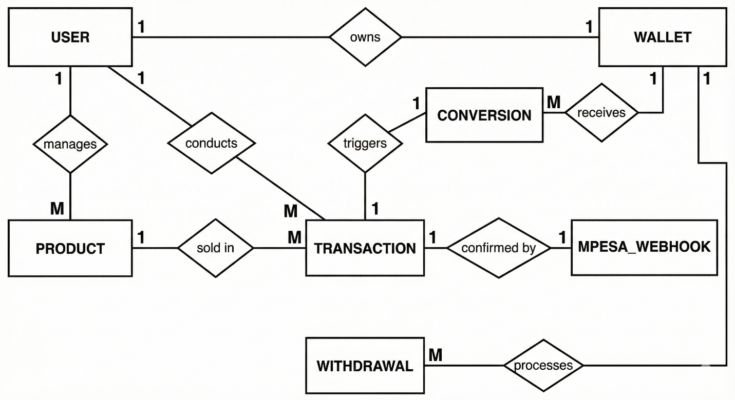
Figure 1: Entity relationship diagram

Class Diagram
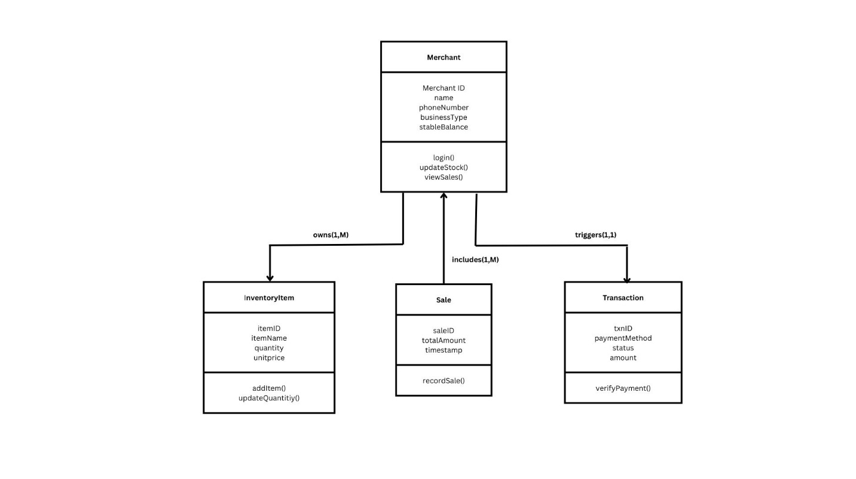
Figure 2: Class Diagram

Data Flow Diagram (DFD)
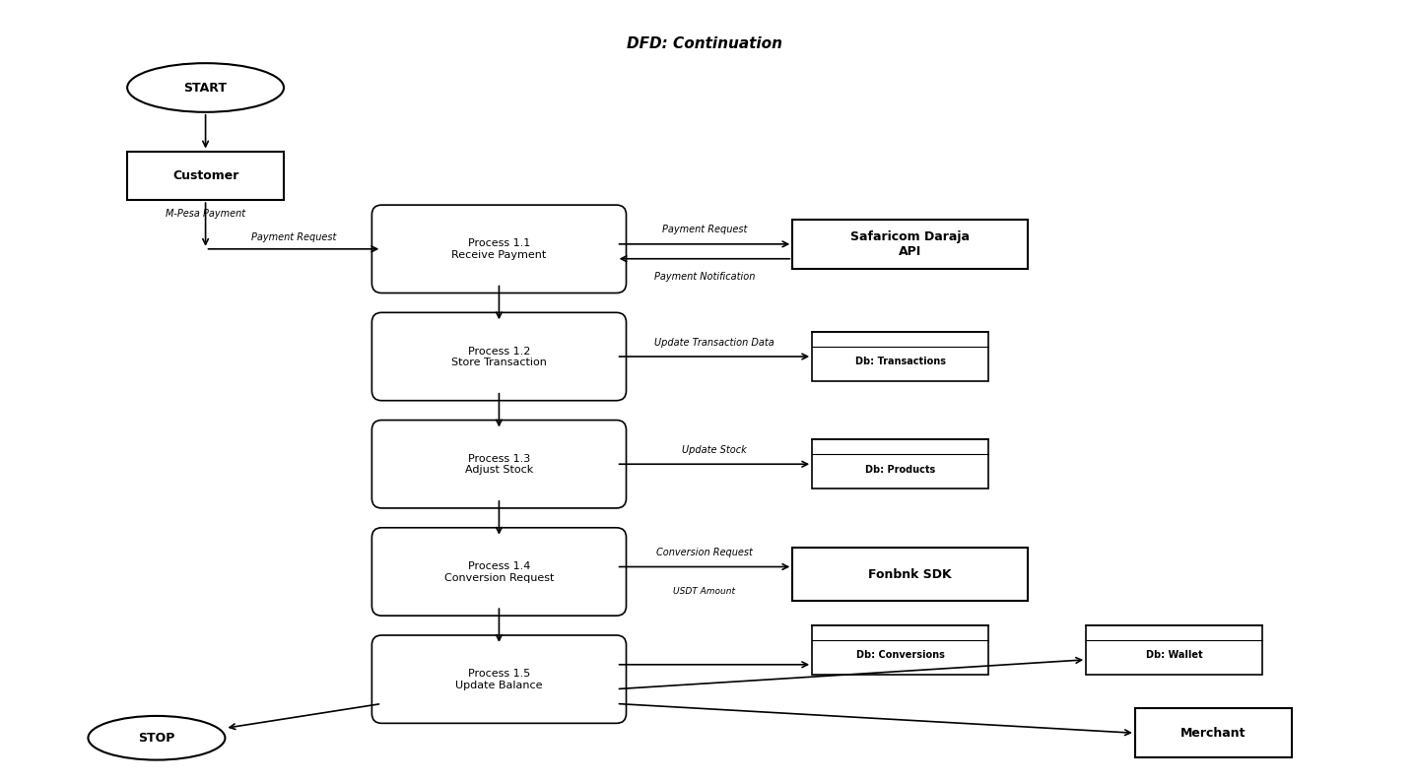
Figure 3: Data Flow Diagram

. Use Case Diagram
• 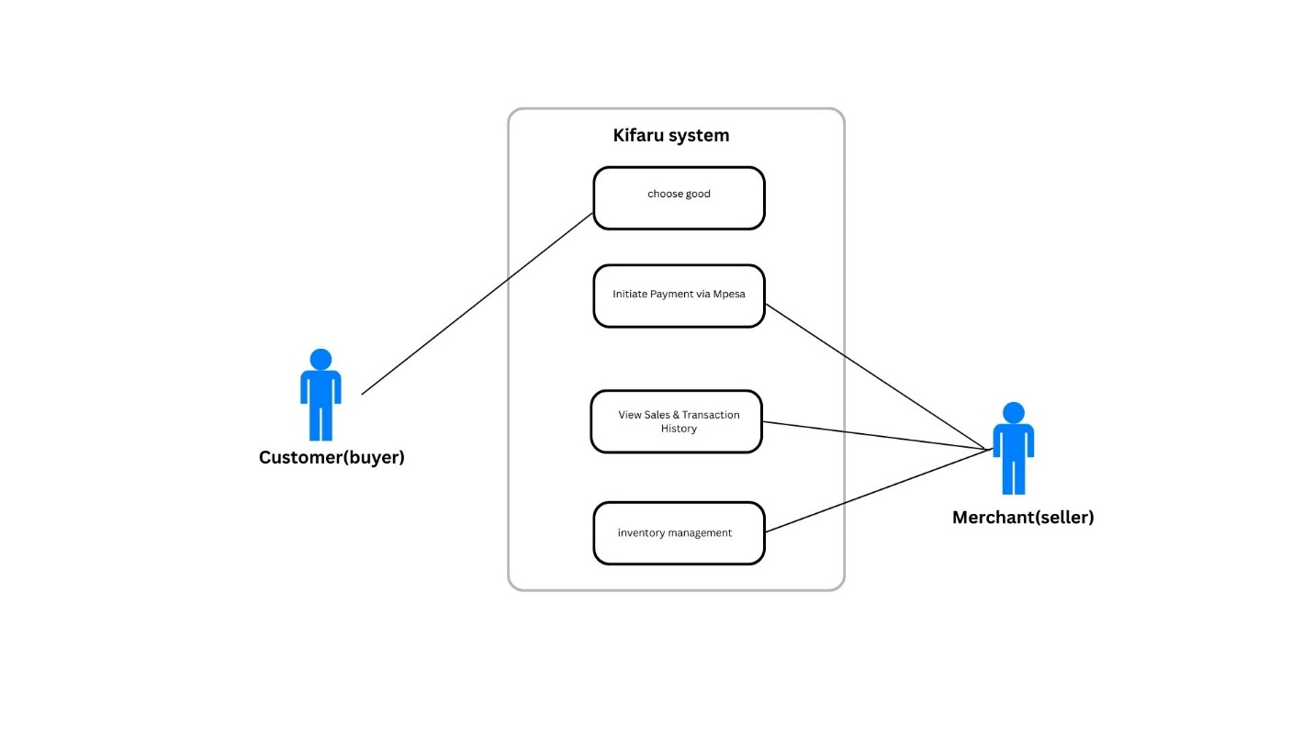
Figure 4:Use case Diagram

IMPLEMENTATION, TESTING AND RESULT

Introduction
This chapter presents the implementation details of the Kifaru platform, describing the tools, technologies, design patterns, and coding techniques employed during development. It also outlines the testing strategy adopted to verify the system and presents the results achieved during the development and evaluation phases. The chapter demonstrates how the system requirements identified in earlier chapters were translated into a functional, secure, and user-friendly platform.

4.1 Implementation Approach
Kifaru was developed as a full-stack web application using modern JavaScript and TypeScript technologies. The system follows a layered architecture separating concerns into distinct frontend and backend components, each containerised using Docker for consistent deployment across development and production environments. The implementation prioritised security, scalability, and ease of use for merchants with varying levels of digital literacy.

4.1.1 Programming Languages and Frameworks
The backend was built using Node.js (version 22) with Express.js 5.1.0 as the web framework, written entirely in TypeScript 5.8.3. TypeScript was selected for its static type checking, which reduces runtime errors and improves code maintainability in a financial application where data integrity is critical. Express.js was chosen for its lightweight, unopinionated architecture that allows fine-grained control over middleware, routing, and error handling (Tilkov & Vinoski, 2010).
The frontend was developed using Next.js 14.2.4 with the App Router architecture and React 18.3.1. Next.js was selected for its server-side rendering capabilities, file-based routing, and built-in performance optimisations that enhance the user experience for merchants accessing the platform on varying internet connections. The user interface components leverage Ant Design 5.25.4, a comprehensive React UI library, complemented by Tailwind CSS 3.4.17 for custom styling.

4.1.2 Database and Data Storage
PostgreSQL was selected as the primary database, hosted on Supabase, a managed cloud database platform. PostgreSQL was preferred over alternatives like MongoDB due to its support for ACID transactions, which are essential for financial operations such as payment processing and inventory adjustments. The database schema comprises seven core tables: merchants, Products, Categories, Suppliers, ProductVariants, StockMovements, and Transactions. Foreign key constraints enforce referential integrity, while database-level CHECK constraints validate enumerated values such as stock movement types (IN, OUT, ADJUSTMENT, SALE, RETURN). Strategic indexes on frequently queried columns such as merchant_id, product_id, and created_at optimise query performance.

4.1.3 Authentication and Security
User authentication is implemented using JSON Web Tokens (JWT) with a seven-day expiration period. Passwords are hashed using bcrypt with a cost factor of ten salt rounds before storage, ensuring that even in the event of a database breach, user credentials remain protected. A custom middleware function verifies the JWT on every protected route, extracting the merchant_id from the token payload to enforce multi-tenant data isolation. This approach prevents Insecure Direct Object Reference (IDOR) vulnerabilities by ensuring all database queries include the authenticated merchant_id in their WHERE clauses.

4.1.4 Payment Integration
Payment processing is implemented through the Fonbnk Pay Widget, which enables customers to pay in Kenyan Shillings (KES) via M-Pesa while merchants receive the equivalent value in USDT on the Celo blockchain. The integration follows a webhook-driven architecture. When a customer initiates a payment, the backend generates a JWT-signed widget URL containing the merchant wallet address, transaction amount, and a unique identifier to prevent replay attacks. The frontend renders the Fonbnk widget inside an iframe, and upon payment completion, Fonbnk sends a webhook notification to the backend.
Webhook security is enforced through SHA-256 signature verification using a shared secret. The system supports multiple webhook payload formats to accommodate different Fonbnk API versions and implements fallback matching logic that can reconcile transactions by amount (with a tolerance of plus or minus one KES) within a two-hour window when order identifiers are unavailable. This robust matching ensures that no legitimate payments are lost due to format inconsistencies.

4.2 Design Patterns
The system employs several established software design patterns to ensure maintainability, testability, and separation of concerns.
Repository Pattern: All database access is abstracted through repository modules (inventoryRepository, categoryRepository, transactionRepository). This pattern isolates SQL queries from business logic, enabling the service layer to operate independently of the underlying data source. Each repository provides both standalone query methods and transaction-managed variants (using WithClient suffixes) that accept a shared database client for atomic operations.
Service Layer Pattern: Business logic is encapsulated in service modules that orchestrate operations across multiple repositories. For example, the inventoryService coordinates stock adjustments, movement logging, and alert generation within a single transactional boundary, ensuring data consistency even when multiple tables are affected.
Middleware Pattern: Cross-cutting concerns such as JWT verification, asynchronous error handling, and CORS configuration are implemented as Express middleware functions. The asyncHandler wrapper captures unhandled promise rejections and forwards them to a global error handler, preventing server crashes from uncaught exceptions.
ACID Transactions: Critical multi-step operations such as the checkout process use explicit BEGIN, COMMIT, and ROLLBACK statements to ensure atomicity. The checkout flow verifies product availability, creates a transaction record, deducts stock for each item, and marks the transaction as completed within a single database transaction. If any step fails, the entire operation is rolled back to maintain data integrity.

4.3 How the System Works
The Kifaru platform operates through an integrated workflow that connects payment processing, inventory management, and value preservation into a seamless merchant experience.
Dashboard: Upon logging in, merchants are presented with a responsive dashboard built using a sidebar navigation layout. The sidebar provides access to all core modules: Point of Sale (POS), Inventory Management, Categories, Suppliers, Reports, Transactions, and Wallet Management. The dashboard layout features a collapsible sidebar (250 pixels wide) with smooth CSS transitions and a fixed header displaying the merchant username and logout controls.
Point of Sale: The POS module allows merchants to search and filter products, add items to a shopping cart with quantity management, and process checkouts. Real-time stock availability checking prevents overselling. When a customer is ready to pay, the system initiates the Fonbnk checkout flow, generating a signed widget URL and rendering the payment interface within a modal. Cart totals are calculated using authoritative database prices rather than client-supplied values, preventing price manipulation.
Inventory Management: Merchants can create, update, and delete products with full detail management including SKU codes, pricing, category assignment, supplier linking, and image uploads via Cloudinary integration. Stock adjustments are recorded with movement types (IN, OUT, ADJUSTMENT, SALE, RETURN), creating a complete audit trail with stock-before and stock-after snapshots. The system automatically generates low-stock alerts when product quantities fall below configurable thresholds (default: ten units).
Reports and Analytics: The reports module provides merchants with data-driven insights through multiple report types: inventory summary (total products, stock units, and inventory value), low-stock reports, stock movement reports with date-range filtering, and inventory valuation breakdowns by category. Charts and visualisations are rendered using the Recharts library, giving merchants clear visual representations of their business performance.
Transaction Logging: Every sale processed through the POS is logged as a transaction record containing the total amount, currency, status (PENDING, COMPLETED, or FAILED), customer details stored as JSONB, and payment metadata including Fonbnk order identifiers and webhook data. Merchants can view their complete transaction history with pagination support.

4.4 Deployment Architecture
The system is containerised using Docker with a docker-compose configuration that orchestrates the frontend and backend services. The frontend runs as a Next.js standalone server on port 3000 (mapped externally to port 3500), while the backend Express server runs on port 4000. Both services are deployed as pre-built Docker images (godwin005/nextjs-frontend and godwin005/kifaru-backend). The database is hosted on Supabase, a managed PostgreSQL service, eliminating the need for local database administration. Database migrations are managed through sequential SQL files stored in a dedicated migrations directory, ensuring reproducible schema changes across environments.

4.5 Testing
A multi-layered testing strategy was adopted to verify the correctness, reliability, and security of the Kifaru platform. The testing framework comprises unit tests, integration tests, and end-to-end tests, all implemented using Jest 30.2.0 with TypeScript support via ts-jest 29.4.6.

4.5.1 Unit Testing
Unit tests focus on the service layer, isolating business logic from database dependencies through Jest mocking of repository modules. Key test cases for the inventory service validate that stock increases and decreases are calculated correctly, that the system prevents negative stock quantities (a critical business rule), that low-stock alerts are triggered when quantities fall to or below the configured threshold, and that inventory summary calculations produce accurate totals. The category service tests verify hierarchical category tree construction and merchant-level authorisation checks.

4.5.2 Integration Testing
Integration tests verify the interaction between controllers, services, and repositories using Supertest 7.2.2 for HTTP endpoint simulation. These tests confirm that the stock adjustment API endpoint correctly processes authenticated requests, that report generation returns properly structured data, and that multiple sequential operations maintain data consistency. Authentication middleware is tested to ensure that protected routes reject requests without valid JWT tokens.

4.5.3 End-to-End Testing
End-to-end tests validate complete business workflows from start to finish. The sale flow test simulates the entire purchase lifecycle: product setup, cart addition, checkout processing, stock deduction verification, and transaction logging confirmation. These tests ensure that the atomic checkout process correctly deducts inventory, creates transaction records, and maintains data integrity across all affected tables.

4.6 Results
The development of the Kifaru platform achieved all three specific objectives outlined in the project proposal.
Objective 1 — Automate inventory tracking and sales record management: The system successfully automates inventory updates whenever a sale is processed through the POS. Stock levels are adjusted in real time within atomic database transactions, and every movement is logged with a complete audit trail including timestamps, quantities, and reference identifiers. Merchants no longer need to manually update stock records after each sale, eliminating the double-workload problem identified in the problem statement.
Objective 2 — Allow customers to make payments using normal currency while merchants receive value securely in USDT: The Fonbnk integration enables customers to pay using M-Pesa (KES) while the merchant receives the equivalent value in USDT on the Celo blockchain. The webhook-driven architecture ensures reliable payment reconciliation with multiple fallback matching strategies. This protects merchant earnings from local currency depreciation without requiring customers to change their payment habits.
Objective 3 — Provide merchants with an organised dashboard for monitoring income and stock: The responsive dashboard provides comprehensive business intelligence through inventory summaries, low-stock alerts, stock movement reports, valuation breakdowns by category, and transaction history. Charts rendered using Recharts give merchants visual insight into their business performance, supporting data-driven decision-making.
The test suite confirms the reliability of core functionalities. Unit tests validate that business rules such as negative stock prevention and alert triggering operate correctly. Integration tests confirm that API endpoints handle authentication, input validation, and error conditions appropriately. End-to-end tests verify that complete sale workflows maintain data integrity across the Products, StockMovements, and Transactions tables. The multi-tenant architecture successfully isolates merchant data, preventing unauthorised cross-merchant access.

CONCLUSION, EVALUATION AND FURTHER WORK

5.1 Introduction
This chapter presents a critical evaluation of the Kifaru project, reviewing how the objectives set out in Chapter One were met during the development process. It also discusses the challenges encountered, proposes directions for future development, and concludes with an assessment of the overall contribution of the project.

5.2 Review of Objectives
The main objective of this project was to develop a secure and user-friendly platform that enables merchants to receive payments efficiently and manage their inventory in real time. This objective has been achieved through the delivery of the Kifaru web application, which integrates payment processing, automated inventory management, and stable-value digital cash preservation into a unified platform.
Specific Objective 1: Automate inventory tracking and sales record management. This objective was fully achieved. The system automatically adjusts stock levels when sales are processed through the Point of Sale module. Every inventory change is recorded in the StockMovements table with movement type classification (IN, OUT, ADJUSTMENT, SALE, RETURN), stock-before and stock-after snapshots, and reference identifiers linking movements to their originating transactions. Low-stock alerts are triggered automatically when product quantities fall below configurable thresholds, ensuring merchants are informed before stockouts occur. The complete audit trail replaces the manual record-keeping methods that previously led to errors and inventory losses.
Specific Objective 2: Allow customers to make payments using normal currency while merchants receive value securely in USDT. This objective was achieved through the Fonbnk Pay Widget integration. Customers pay using M-Pesa in Kenyan Shillings, which is the payment method they are already familiar with, while merchants receive the equivalent value in USDT on the Celo blockchain. The webhook-driven reconciliation system with SHA-256 signature verification and multiple fallback matching strategies ensures reliable payment processing. This mechanism addresses the currency depreciation challenge identified in the problem statement by allowing merchants to hold earnings in a dollar-pegged digital asset.
Specific Objective 3: Provide merchants with an organised dashboard for monitoring income and stock. This objective was achieved through the development of a comprehensive dashboard interface. The dashboard provides real-time inventory summaries showing total products, stock units, and inventory value. The reports module offers multiple report types including low-stock alerts, stock movement analysis with date-range filtering, and inventory valuation breakdowns by category. Transaction history with search and pagination enables merchants to review their sales records efficiently. Charts and visualisations powered by the Recharts library present business data in accessible visual formats.

5.3 Future Developments
Several enhancements could improve the Kifaru platform and expand its functionality in future iterations.
First, the development of a mobile application using React Native or Flutter would extend the reach of the platform to merchants who primarily access the internet through smartphones. A mobile-first approach would be particularly valuable in the Kenyan market, where mobile device usage far exceeds desktop usage among small merchants.
Second, the integration of SMS-based notifications for low-stock alerts and transaction confirmations would benefit merchants who may not have constant access to the web dashboard. This feature could leverage the existing nodemailer infrastructure to include SMS gateway integration.
Third, the implementation of advanced analytics using machine learning algorithms could provide merchants with predictive inventory forecasting, identifying seasonal demand patterns and recommending optimal reorder quantities. Such features would further reduce inventory losses from overstocking or stockouts.
Fourth, expanding the payment options to include direct bank transfers, card payments, and additional mobile money providers beyond M-Pesa would broaden the customer base that merchants can serve through the platform.
Finally, a supplier management portal that enables direct communication and automated reordering between merchants and their suppliers would create a more complete supply chain management solution.

5.4 Challenges Faced
Several challenges were encountered during the development of the Kifaru platform. The integration with the Fonbnk API presented significant complexity due to evolving webhook payload formats across different API versions. This required the implementation of multiple payload parsing strategies and fallback matching logic to ensure no legitimate payments were lost during reconciliation.
Ensuring transactional integrity across payment processing and inventory updates required careful database transaction management. The atomic checkout process needed to handle edge cases such as concurrent purchases of the same product, network failures during webhook delivery, and partial payment completions. The solution involved explicit database transaction control with BEGIN, COMMIT, and ROLLBACK statements, combined with idempotent webhook handling.
The regulatory landscape surrounding digital assets in Kenya presented challenges in designing the system architecture. The Central Bank of Kenya continues to develop its regulatory framework for digital financial services, requiring the system to be designed with compliance flexibility. The decision to use Fonbnk, a licensed financial technology provider, rather than building direct blockchain interactions helped mitigate regulatory risk.
Testing the payment flow end-to-end was challenging because the Fonbnk sandbox environment did not always replicate production webhook behaviour exactly. This required extensive logging and manual verification during the integration testing phase to ensure that the webhook handling logic was robust enough for production use.

5.5 Conclusions
The Kifaru project successfully demonstrates that an integrated digital solution can address the interconnected challenges of manual inventory management, payment reconciliation, and currency depreciation faced by small and medium-sized merchants in Kenya. By combining automated inventory tracking with M-Pesa payment acceptance and stable-value digital cash preservation, the platform offers a practical improvement over the fragmented manual processes that currently dominate the merchant landscape.
The system architecture, built on a modern TypeScript stack with PostgreSQL, Express.js, and Next.js, provides a solid foundation for future development and scaling. The multi-layered security approach encompassing JWT authentication, bcrypt password hashing, webhook signature verification, and multi-tenant data isolation ensures that merchant data and financial transactions are protected against common security threats.
The project contributes to the growing body of work on financial technology solutions for emerging markets by demonstrating how stable-value digital instruments can be integrated into everyday merchant workflows without requiring users to understand the underlying blockchain technology. By abstracting the complexity behind a familiar M-Pesa payment experience, Kifaru validates the approach advocated in the literature review: that technology adoption among merchants depends on perceived usefulness and perceived ease of use, consistent with the Technology Acceptance Model (Davis, 1989).
The relationship between this project and the Computer Science degree programme is significant. The project applied principles from software engineering, database design, computer security, web development, and human-computer interaction to solve a real-world problem. The hybrid SDLC-Agile methodology ensured both technical rigour and responsiveness to user feedback, reflecting the balanced approach to software development taught within the programme. The challenges encountered, particularly in payment integration and regulatory compliance, provided valuable learning experiences that extend beyond the academic curriculum into practical professional competencies.
References (APA 7)
Advanced Trade. (2023). Global settlement volume for stablecoins reaches $7 trillion. Advanced Trade. Advanced Trading
BCG. (2024). Stablecoins: Five killer tests to gauge their potential. Boston Consulting Group. BCG Media Publications
Central Bank of Kenya. (2024). Annual Report 2024. Central Bank of Kenya. Central Bank of Kenya
Central Bank of Kenya. (n.d.). Foreign exchange rates. Retrieved from Central Bank of Kenya website. Central Bank of Kenya+1
Chainalysis. (2024). Global Crypto Adoption Index 2024. Chainalysis. Chainalysis
FSD Kenya. (2024). Micro, Small and Medium Enterprises outlook report. Financial Sector Deepening Kenya. Financial Sector Deepening Kenya
GSMA. (2023). The State of the Industry Report on Mobile Money 2023. GSMA. GSMA
Mercy Corps / Valiu. (n.d.). Valiu: Leveraging crypto to reach the displaced. Mercy Corps Ventures. Mercy Corps
Safaricom PLC. (2023). Safaricom Annual Report 2023: M-Pesa. Safaricom PLC. Safaricom+1
TechCabal. (2025). How OTC trading and stablecoins could transform African payments. TechCabal Insights. TC Insights+1
World Bank. (2010). Mobile payments go viral: M-Pesa in Kenya. World Bank
Berkeley Haas Lab for Inclusive Fintech. (2021). Pilot Launch | Crypto wallet and remittance service for unbanked Venezuelan refugees. Medium / Berkeley Haas. Retrieved from https://haas.berkeley.edu/ibsi/about-the-institute/blog/posts/pilot-crypto-wallet-and-remittance-service-for-unbanked-venezuelan-refugees/ (Mercy Corps pilot coverage).
Chainalysis. (2024). Global Crypto Adoption Index 2024. Chainalysis. Retrieved from https://www.chainalysis.com
Contxto. (2021, December 13). Valiu, key to Venezuelan remittances, announces its closure. Contxto. Retrieved from https://contxto.com/en/news/valiu-key-to-venezuelan-remittances-announces-its-closure/
Mercy Corps. (n.d.). Valiu: Leveraging crypto to reach the displaced. Mercy Corps. Retrieved from https://www.mercycorps.org/what-we-do/ventures/valiu
Mercy Corps Ventures. (2019). Why we invested in Valiu (blog). Medium / Mercy Corps Ventures. Retrieved from https://medium.com/mercy-corps-social-venture-fund/why-we-invested-valiu-496b4630a523
Safaricom PLC. (2023). Safaricom Annual Report 2023: M-Pesa (for Kenyan payments context). Retrieved from https://www.safaricom.co.ke
Central Bank of Kenya. (2024). Annual Report 2024 (for exchange-rate and macro context). Retrieved from https://www.centralbank.go.ke
FSD Kenya. (2024). Micro, Small and Medium Enterprises outlook report. Financial Sector Deepening Kenya. Retrieved from https://fsdkenya.org
TechCabal. (2024). Kenya opens up to fintech payment licences (for regulatory context). Retrieved from https://techcabal.com/2024/06/10/kenya-opens-up-to-fintech-payment-licenses/

APPENDIX
